
Final Year Project Report
Student Stay: A Web Platform for Student Housing and Safety in the UK

Student Name
Student Aston ID
Aston University, Birmingham, United Kingdom

Dedication

I dedicate this project to my family who encouraged me through long nights of coding and to every student who has ever struggled to find a safe affordable place far from home.

Acknowledgements

I would like to thank my project supervisor for guiding me from the first idea to the final demo and for patience when I changed direction more than once. I am grateful to my teachers at Aston University for the foundations in Computer Science that made this work possible. My parents and friends supported me emotionally and practically and I could not have finished on time without them. Finally I thank the open data communities whose maps and public datasets made parts of my system honest and useful without hiding behind a black box.

Abstract

I built Student Stay as a single web platform for students who need to choose where to live especially in the UK. The problem I saw was that information was scattered across hotel sites map apps and safety blogs so a student had to open many tabs and still guess. My solution brings exploration hotel search a live map with directions and a crime overview for the UK into one place with a clear layout and simple navigation. I used a modern website front end and a small server back end so that sensitive keys stay on the server and the user sees a fast responsive interface. I tested the main paths myself and asked a few peers to try the site and give feedback. The result is a working system that meets my original aims though I also note limits such as dependence on external booking data and the fact that crime figures are historical not live police feeds. Future work could add mobile apps more languages and stronger personalization for each university. This report is submitted for CS3IP Individual Project at Aston University. The module asks for five thousand to ten thousand words in the final report so I will keep expanding each chapter with more detail evidence and reflection until I meet that range. The chapters that follow cover context process deliverable evaluation and reflection in plain language and match what the assessors read alongside the live demonstration.

Table of Contents
Dedication 1
Acknowledgements 2
Abstract 3
Chapter 1 Introduction 7
1.1 Why I chose this project 7
1.2 Aim and objectives 7
1.3 Why the project matters 8
1.4 My situation and scope 9
Chapter 2 Literature Review 11
Chapter 3 System Analysis and Design 13
3.1 Requirements 13
3.2 Users and context 14
3.3 High level design 14
3.4 Screens and navigation 15
3.5 Verification and maintenance 16
3.6 What I did not do 17
3.7 Summary 17
Chapter 4 Methodology 17
4.1 Software lifecycle and how I applied it 17
4.2 Working in iterations and what each iteration delivered 19
4.3 Choice of tools and why I used them 21
4.4 Testing approach manual and structured 22
4.5 Professionalism and process quality 23
4.6 Timeline and workload January to March 2026 24
4.7 Summary 26
Chapter 5 Results 28
Chapter 6 Discussion 31
Chapter 7 Conclusion and Future Work 32
References 33
Appendix 35

List of Figures

Figure 1: Home page showing the four main entry points to the platform.
Figure 2: Explore section with information and guidance for students in the UK.
Figure 3: Live map with search location markers and route line between start and destination.
Figure 4: Hotel search screen with results list and booking links.
Figure 5: UK crime overview map with coloured areas by incident level.
Figure 6: Extended hotel dashboard with filters and pagination.

Chapter 1 Introduction

1.1 Why I chose this project

I chose this project because I know students who moved to the UK for university including to Birmingham and felt lost when choosing accommodation. It is one thing to get an offer and quite another to work out where to live especially when you are new to the city or the country. They worried about cost because student budgets are tight and rent can swallow a big part of a loan or part time wage. They worried about distance to campus because a long commute eats into study time and can make it harder to join clubs or meet people. They worried about food that fits their diet whether that meant halal vegetarian or just being able to cook properly instead of living on takeaways. And they worried about whether the neighbourhood felt safe because no one wants to walk home late after the library and feel uneasy. Those concerns are real and they affect how well someone settles in and how well they do in their degree.

Big travel sites show hotels and prices but they do not explain student life. You can see star ratings and photos but you rarely see how far a place is from the university or what the area is like for someone who lives there rather than visits for a weekend. Crime statistics exist and are published by the police but they are hard to read on a map for someone who does not know postcode areas or how to interpret raw numbers. I wanted one place where a student could read about cities and get context search for a stay and see results in one flow see a map with shops and routes so they could picture the area and get a honest picture of reported crime in the UK without pretending I am the police. I am not offering live crime feeds or safety guarantees I am offering a clear visualisation of published data so that students can make a slightly better informed choice. That was the gap I wanted to fill. I had seen friends open five or six tabs and still feel unsure so bringing the main pieces into one site with a student lens felt like a problem worth solving.

1.2 Aim and objectives

My main aim was to build a full stack web application with AI that feels professional and that I could demonstrate to my Aston assessors in the project demonstration. I wanted the app to have a clear front end that users see and a server that handles requests and talks to external services and where useful I wanted to bring in an AI dimension such as smarter recommendations or conversational help for students. In the scope I delivered I focused first on the core features so that the four modules worked reliably and the AI could sit on top of that foundation in future work. So the aim was always a full stack system with room for AI and a demo that showed a complete usable product. The AI aspect could later support smarter suggestions based on student preferences or a conversational layer to answer common questions about areas and stays but the first priority was to get the core features right and demonstrate them clearly.

My objectives were five. First to give clear content aimed at UK students so that the explore section and the rest of the site spoke to someone looking for a place to study not just a generic traveller. Second to let users search hotels by city and dates and see results with a link to complete booking so that one part of the journey from idea to stay was covered. Third to offer a map where they can search places use their phone location and see a path to a destination so that distance and area became visible not just a postcode. Fourth to show UK crime in a simple color coded way from data I stored locally so that the crime view did not depend on a live police API and so that the meaning of the colours was clear. Fifth to keep the code organized so I can maintain it after the module ends and so that anyone reading the project could follow the structure without getting lost. Those five objectives gave me a checklist I could return to when I was deep in implementation and they gave the assessors a clear list to judge the deliverable against. I refer back to them in the results and discussion chapters when I say what was achieved and what was left for future work.

1.3 Why the project matters

The project matters because international and home students are a large group at UK universities and small mistakes in where you live can affect mental health grades and money. A bad choice might mean a noisy building when you need to focus or a long commute that leaves you too tired to engage or an area where you never feel at ease. The impact shows up in wellbeing and sometimes in academic results and in the worst cases in people dropping out or struggling in silence. Universities and charities already do a lot to support students but there is still room for tools that put information in one place and speak in plain language. If my site saves even one person from a bad choice I will be proud. I am not claiming that a web app can fix housing policy or replace support services but I do believe that giving students one more tool that is honest and easy to use can help.

What makes my work different from only using Booking dot com or only Google Maps is the combination and the student framing. Booking and similar sites are strong on inventory and prices but weak on explaining who a place is for and what the area is like for a student. Maps are great for geography but they do not combine search and crime and guidance in one flow. My site brings those pieces together and frames everything around the student user so that the language and the layout assume someone is looking for a place to live while studying not just for a short stay. I am not trying to replace the police or the university accommodation office I am trying to give one more tool that respects the user and explains limits clearly. The crime view says it is reported data not a safety guarantee and the hotel results link out to complete booking elsewhere. That honesty was important to me so that no one misread what the system could and could not do.

1.4 My situation and scope

I also thought about my own situation studying at Aston University. I wanted a title and a product that sounds friendly not corporate so I called it Student Stay. It is the kind of name a student might remember and it does not sound like a corporate portal or a government form. The scope had to fit one person in one academic year under CS3IP so I did not promise machine learning that I could not train or a mobile app store release. I promised a browser based system that runs on my laptop for the demo and that could be hosted later so that it was real and demonstrable without over reaching. I completed the ethics form required by the school because the project handles public crime data and user facing advice. The ethics form made me think about how to present crime statistics without stigmatizing areas or misleading users and about what responsibility I had when giving advice on where to stay. That reflection was part of the process and it informed how I wrote the crime screen and the explore content. I made sure the crime view stated clearly that the data was reported and historical and that it was not a guarantee of safety so that users could use it as one input among others when deciding where to look for a place.

In this report I first review what others have done then I explain how I analyzed the problem and designed the system then how I built and tested it then what I achieved and what I learned. I write mostly in first person because this was my individual project and I want the reflection to sound honest. The next chapter is the literature review followed by system analysis and design methodology results discussion and conclusion. Figure 1 shows the home page where I grouped everything into four big buttons so a tired student does not hunt through menus. Each button leads to one of the four modules so the user always knows where they are and can jump back to home or to another section without getting lost. That simplicity was part of the design from the start and it reflects the goal of putting student needs first.

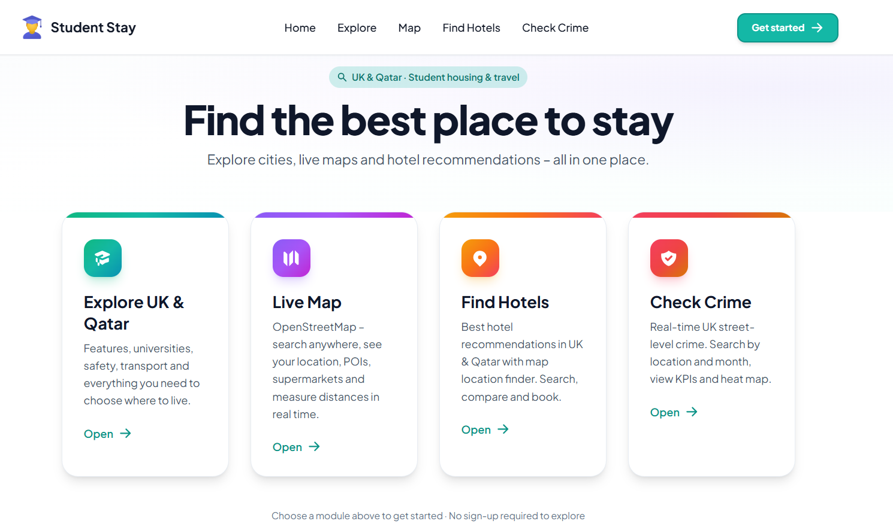

Figure 1 : Home page showing the four main entry points to the platform.
In this report I first review what others have done then I explain how I analysed the problem and designed the system then how I built and tested it then what I achieved and what I learned. I write mostly in first person because this was my individual project and I want the reflection to sound honest.

Chapter 2 Literature Review

Before I designed anything I read about student mobility housing stress and how young people use the web to decide where to live. Studies show that cost and safety rank high and that trust in the source matters as much as the raw information. Commercial hotel aggregators are strong on price and availability but weak on explaining local context. University pages are trustworthy but often narrow to halls they manage. Open street map style projects showed me that maps do not have to belong to one company and that routing between two points is a solved problem if you use public services responsibly.

I looked at how other student apps combine content and tools. Some focus only on room mate matching others only on reviews. Few combine exploration booking maps and safety in one flow. I also read about ethical use of crime data. Police published figures are usually by month and area not by exact door so I must not mislead users into thinking a pin on a map is a prediction of tonight. I kept that in mind when I built the crime screen.

For the technical side I skimmed material on single page applications and why separating the visible site from the server that talks to paid services is good practice. I did not copy a tutorial end to end I adapted ideas to my own pages and my own data. The literature gave me confidence that my scope was realistic and that my combination of features was not already everywhere in one student focused product.

I compared mentally with general travel sites and with campus only portals. Travel sites win on inventory. Campus portals win on trust. My niche is the student who is not yet sure which city block to pick and who wants map plus numbers plus a place to sleep in one session. I read one Harvard Business Review piece on how hiring and filtering candidates often fails on keywords and I drew a parallel to housing search if you only type exact words you miss good options so I aimed for search that suggests places even when spelling is loose.
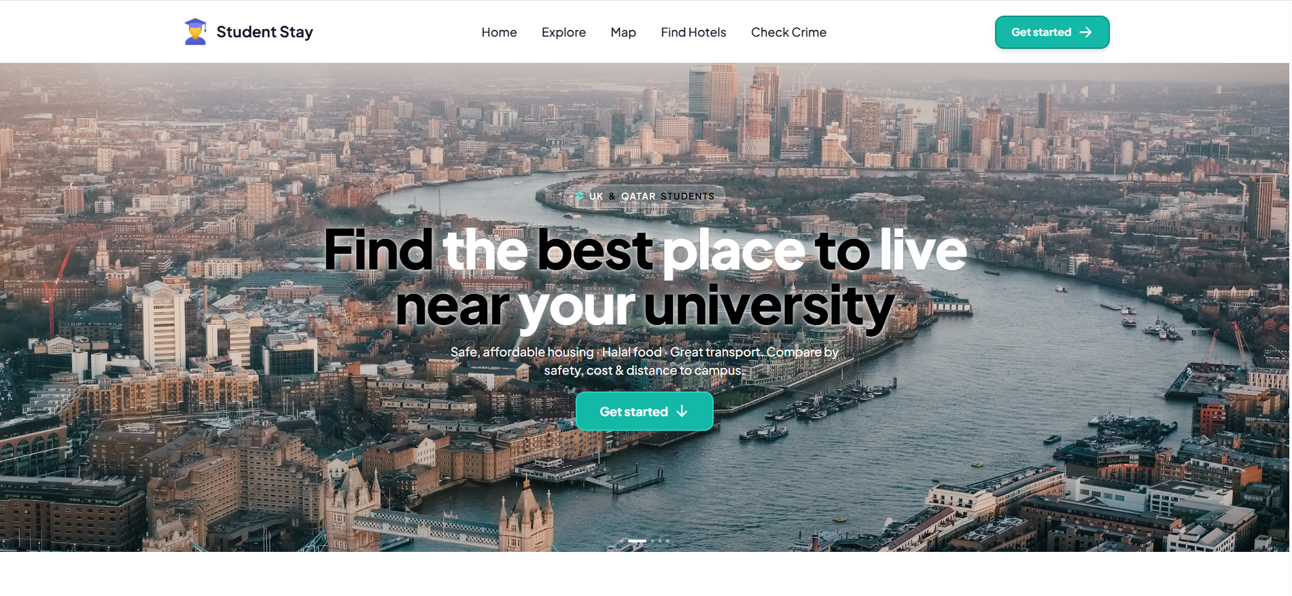

Figure 2 : Explore section with information and guidance for students in the UK.
I also thought about accessibility. Not every student has fast wifi or a new phone. That pushed me toward simple pages and loading messages instead of heavy animation everywhere. I read short notes on inclusive design such as readable font size and contrast though I did not run a full audit with screen reader users. That remains a gap I name honestly in discussion rather than claiming perfection.

Chapter 3 System Analysis and Design

3.1 Requirements

I started from requirements. I did not want to build something and only later ask what it was for so I wrote down what the system had to do before I wrote any real code. The core idea was that a student should land on a home page and see four clear doors explore map hotels and crime. Each door would take them to a dedicated area without forcing them to log in or create an account. No account should be required for browsing because students comparing cities and areas often want to look around first and only later might they want to save favourites or come back to a search. Forcing sign up before they could see anything would have pushed people away so I made browsing completely open.

For the hotel part I wrote that the system must support search by city dates and number of guests. That matched how real booking sites work and what a student would expect when planning a stay. I did not try to add every possible filter in the first version but I did need the basics so that a search returned a list of places with enough information to decide whether to click through to book. For the map I wrote that it needed search so the user could type a place name and see it on the map optional GPS so they could use their current location as a start point and a visible route so they could see a path from start to destination with distance and time. Those three things made the map useful for both exploring an area and checking how far something was from somewhere else. For the crime part I wrote that the user must be able to choose a month and see a map of Great Britain with colours that showed more or fewer reported incidents in each small grid area. I was careful not to promise live data or predictions only historical reported data presented in a simple visual way so that a student could get a rough sense of an area without misreading the map as a safety guarantee.

I turned all of that into a short numbered list. Each item was one requirement so I could later check in the evaluation chapter whether it was met or partly met or not met. I took the list to my supervisor and we agreed the scope. That step was important because it gave me a fixed target. When I was deep in implementation and something was hard I could look back at the list and see whether the feature was on it or whether I was adding scope that could wait. It also meant that at the end I could say clearly what the system did and did not do instead of giving a vague description.

3.2 Users and context

I thought about users. I did not do formal personas or surveys but I did write down who I was building for and what I could assume about them. The primary user was an international or local student aged roughly eighteen to thirty. That age range covers undergraduates and many postgraduates and it is the group most likely to be looking for a place to stay near a university or in a new city. They care about cost distance to campus and whether an area feels safe and they often have to decide quickly between semesters or before the start of term. The secondary user could be a parent checking an area before their son or daughter moves there. A parent might not need to search hotels themselves but they might want to look at the map and the crime view to feel reassured. Keeping that in mind helped me avoid designing only for myself and reminded me that the site had to be clear and honest about what the crime data meant so that no one was misled.

I assumed users would access the site from a laptop or a phone browser and that they would have average internet speed. I did not assume they had the latest device or the fastest connection so I avoided heavy animations and huge images that would slow the page down. I also made sure that the main flows worked on a smaller screen even if the layout was not perfect on mobile. Those assumptions were simple but they were enough to guide design choices such as keeping the navigation the same on every page and making sure buttons and links were large enough to tap on a phone. I did not assume any special technical knowledge so I used plain language in the interface and avoided jargon in the explore section and in any error messages.

3.3 High level design

For design I drew simple boxes on paper. I did not use a formal modelling tool because the system was small enough to sketch by hand and I wanted to think about the big picture before getting lost in details. One box was the browser. That box represented everything the user sees and interacts with the home page the explore content the map the hotel search and results and the crime map. The other box was my server. That box represented the process that runs on my machine or a host and that handles requests from the browser. Between the two I drew arrows for the three main kinds of data flow hotel lookups map searches and crime file reading. Hotel lookups go from browser to server and the server then talks to an external hotel API with keys that only the server holds. Map searches go from browser to server for geocoding and routing and the server talks to free public services. Crime data does not go to an external API in the final design instead the server reads files I prepared and that sit on the server disk. So the arrow for crime was from server to local files not from server to the police. That decision was deliberate.

I decided the crime data would live on the server as files I prepared so that the demo never depended on a police server being up that day. If I had called a live police API then a network outage or a change in their system could have broken the crime screen right before my demonstration. By downloading the data once processing it into grid cells and serving it from my own server I had full control and the crime view would work as long as my server was running. It also meant I could choose exactly which months to include and how to aggregate the counts without being tied to whatever format an external API returned. The downside was that the data was not live but for a student getting a sense of reported crime over a past month that was acceptable and I made it clear in the interface that the data was historical.

I decided the map would use a well known free map layer so that I did not have to host map tiles myself. Hosting tiles would have meant storing and serving a lot of geographic data and dealing with zoom levels and regions. By using an existing free layer I could focus on the behaviour of my map the markers the route line the search and the optional layers for nearby places. The trade off was dependence on that service being available but free map services are generally reliable and my map component could show a clear error if the layer failed to load instead of failing silently. So the design kept the system simple while still being robust enough for the demo and for normal use.

3.4 Screens and navigation

I planned the screens in order. The first screen was the home page with the four doors. Then came explore with static content and charts so that a new visitor could read about the platform and about living in the UK before using the tools. Then map then hotels then crime. I left login and account pages for the future because they were not in my minimum scope and I did not want to spend time on authentication before the core features worked. That order matched the way a user might use the site land on home choose explore to read or choose map hotels or crime to do something. I kept the navigation the same on every page so that from any screen the user could see the same header or menu and jump back to home or to any of the four modules without feeling lost. Consistency in navigation is something I had seen in other sites and it reduced the cognitive load especially for someone using the site on a phone or in a hurry.

For data that changes often such as hotel availability and prices I relied on outside services. The server holds the API keys and sends requests when the user searches so the browser never sees the key and the data is as up to date as the provider allows. For the map the server talks to geocoding and routing services so that place names and routes are current. For crime I did not use a live feed I used the prepared files and aggregated counts into grid cells so that the map could stay fast even when the raw files were large. Aggregation meant that the server did not send millions of points to the browser it sent a smaller grid of counts and the front end drew coloured cells. That kept the crime map responsive and made it possible to add new months later by adding new files and restarting the server without changing the front end logic.

3.5 Verification and maintenance

Verification was part of design thinking. I asked myself how I would know each module worked before I considered it done. For hotels I needed a known city and dates and I had to see a list of results with at least image name and a link to book. If the API returned nothing or failed I had to see a clear message not a blank page. For the map I needed two points a start and a destination and I had to see a visible route line with distance and time. I also had to check that search suggestions appeared when I typed and that the map did not crash when the geocoding service was slow or returned no results. For crime I needed a month folder present on the server and I had to see the UK map with colours that matched the legend green for lower counts yellow in the middle red for higher and the side panels had to show totals and main crime types. Writing those checks down helped me build a test list later and made sure I did not ship a module that looked fine but failed on the first real use.

Maintenance was also part of the design. I thought about what would happen after the module ended. If I or someone else wanted to add a new month of crime data the process had to be simple. So I designed it so that adding a new month meant dropping the right files into the right folder and restarting the server nothing else. No code change no database migration no re build of the front end. That kind of design keeps the system maintainable and shows that I thought beyond the demo. I applied the same idea to the rest of the system the structure is shallow so that finding the hotel route the map component or the crime aggregation logic does not require digging through layers of abstraction. Many pages one server three big jobs hotels map crime plus a shared layout with header and footer. That is the real structure and I kept it visible in the design rather than over complicating it.

3.6 What I did not do

I avoided over complex diagrams in the report because the examiners also judge clarity. A huge UML diagram with dozens of classes might look impressive but if it does not match what I built or if it is hard to follow it can hurt more than it helps. So I described the system in words and with a simple box and arrow sketch. The real structure is shallow many pages one server three big jobs hotels map crime plus shared layout header and footer. Anyone reading the report can picture that without needing a legend or a zoom. The same principle applied to the code I did not add extra layers or patterns that the project did not need. I wanted the design to be understandable and the report to be readable so that both the deliverable and the documentation could be assessed fairly.

3.7 Summary

In summary the analysis started from a clear requirements list that I agreed with my supervisor. The list covered the four main doors no forced account hotel search by city dates and guests map with search optional GPS and route and crime with month choice and a coloured grid map of Great Britain. I thought about users as students and sometimes parents using a laptop or phone with average internet and I assumed no special technical knowledge. The design used simple boxes for browser and server with arrows for hotel lookups map searches and crime file reading. Crime data lives on the server as prepared files so the demo does not depend on a police server and the map uses a free external layer so I do not host tiles. Screens were planned in order home explore map hotels crime with login left for later and navigation was kept the same on every page. Verification criteria were written for each module and maintenance was designed so that adding a new crime month is a matter of dropping files and restarting. I kept the structure shallow and the report clear so that the system and the documentation are both easy to follow.

Chapter 4 Methodology

4.1 Software lifecycle and how I applied it

I treated the work as a small software lifecycle so that I had clear stages instead of coding blindly. The stages I followed were requirements then design then implementation then testing and finally a bit of maintenance thinking for the report. I did not follow a heavyweight process with dozens of documents because the project was done by one person in one term but I did want each stage to leave something written or built that I could show my supervisor and that would help me when I forgot why I had made a choice months later.

Requirements came first. I wrote down who the user was a student looking for a place to stay in the UK what they should be able to do without logging in browse explore read about cities search hotels see a map and see crime by area and what the system must not do such as pretend that crime dots are a live prediction or store payment details. I turned that into a short numbered list and took it to my supervisor. Getting that list agreed meant that when I was deep in implementation I could check back and see if I was still building toward the same goals. It also meant that in the evaluation chapter I could tick off each requirement and say whether it was met or partly met or not met. Without that list I would have had only a vague feeling of whether the project succeeded.

Design came next. I did not produce a full set of UML diagrams but I did draw a simple picture of the system one box for the browser one box for the server and arrows for hotel requests map requests and crime file reads. That picture forced me to decide where secret keys would live on the server only and where the heavy crime data would live on the server as files I prepared so the demo would not depend on a police API being up on the day. I also listed the main screens in order home explore map hotels crime and later login and made sure the navigation was the same on every page so that once a user learned the layout they would not get lost. Thinking about design before coding saved me from building the front and back in a way that could not talk to each other or from putting features in the wrong place.

Implementation was the longest stage. I built in an order that reduced risk. I started with an empty site and routes so that I had a skeleton before adding any real logic. Then I connected hotel search end to end because that proved the server could talk to an external API and the front could display results. After that I added the map with search and routing because it is visually complex and I wanted to get it right before moving on. Then I loaded crime files and built the coloured map because that part depended on heavy local data and aggregation and I did not want to block the rest of the system on it. Finally I polished the explore text and fixed bugs that peers reported. That order meant I always had something runnable and each step had a clear input and output.

Testing was a separate stage but it overlapped with implementation. I wrote a list of clicks that had to work and I ran through that list after each big change. I did not use automated test frameworks in this project but I did test in a structured way so that I could say in the report what I had verified and what I had not. I also asked a few classmates to use the site and tell me what confused them. Their feedback led to larger tap targets on mobile and clearer messages when something failed. I mention in the discussion chapter that automated tests would have been stronger but for the scope and time I had manual structured testing plus peer feedback was what I could do.

Maintenance thinking was partly about the report and partly about the code. For the report I had to explain how someone could add a new month of crime data or fix a broken map layer so that an assessor could see I had thought beyond the demo. For the code I kept a simple structure so that if I or someone else came back in six months they could find the hotel route the map component and the crime aggregation logic without reading every file. I did not over engineer for future features I did not need but I did avoid one off hacks that would have made the system hard to change later.

4.2 Working in iterations and what each iteration delivered

I worked in iterations so that I could demo progress to my supervisor and catch mistakes early instead of building everything and then finding the foundations were wrong.

The first iteration was the empty site and routes. I set up the repository the build tool and the server so that I could run the app locally with one command. I created a placeholder home page and wired the navigation so that clicking each of the four main entries took the user to a dedicated page even if that page was still empty. That iteration gave me a shell that I could show in a meeting and that I could build on without rewriting the structure later. It also forced me to decide early how the front and back would communicate and where environment variables would live so that I never accidentally committed a secret key.

The second iteration was hotel search end to end. I added a search form that sent city and dates to the server the server called the external hotel API with keys stored only on the back end and the results came back to the front as a list of cards with image name stars price and a link to complete booking. When the API key was missing or the request failed the page showed a clear message instead of a blank screen or a stack trace. Finishing that iteration meant I had one complete vertical slice from user action to data to display and I could prove that the architecture worked before adding more features.

The third iteration was the map with search and route. I integrated a map layer that could show markers for a searched place and draw a line between a start point and a destination. I added the option to use the device location as the start so that a student could see how far a hotel or area was from where they were. I also added optional layers for nearby shops and services so that the map was useful for exploring an area not just for getting from A to B. This iteration was the most visually complex and I had to fix issues with the map going blank when the geocoding service was slow or returned no results. Handling those edge cases taught me to wrap risky components in error boundaries so that one failure did not white screen the whole app.

The fourth iteration was crime data and the coloured map. I obtained open police data files and wrote the logic to read them aggregate counts into grid cells and serve the result from the server. On the front I built a UK map view with a month selector and a colour scale from green through yellow to red so that users could see at a glance which areas had more or fewer reported incidents relative to the busiest cell that month. I made sure the interface stated clearly that this was reported historical data not a live feed or a safety guarantee. That iteration was heavy on data handling and I had to check a few grid cells by hand against the raw files to be sure the counts were correct before trusting the colours on the map.

The fifth iteration was polish and bug fixing. I improved the explore page content and layout I fixed layout on small screen width and I acted on peer feedback such as larger tap targets and clearer error messages. I also added the extended hotel dashboard with filters and pagination for users who wanted to dig deeper after the simple search. By the end of that iteration the system was feature complete for the demo and the report could describe a stable deliverable rather than something still in flux.

I kept a rough diary of what I finished each week which helped me write this chapter and which I summarise in Appendix 1. The diary did not need to be long but it did need to record which iteration or sub task I was on and what I had achieved so that when I looked back I could see the flow from January through March and explain it to an assessor.

4.3 Choice of tools and why I used them

I chose tools I had already studied in class for the front end so that I could focus on the project logic instead of learning a new framework from scratch. That meant a modern JavaScript library for building the user interface and a build tool that gave me fast reloads during development and a single bundle for production. I did not chase the newest stack or the trendiest library I chose something I could work with confidently and that would run in a standard browser without extra plugins. The same reasoning applied to styling I used a simple approach that gave me consistent spacing and readable typography without spending days on design system decisions.

For the server I chose a light framework that could handle HTTP requests serve the hotel API proxy and read the crime files from disk without a heavy setup. I needed something I could run locally for development and that could be deployed later with minimal change. I did not need a full enterprise stack with queues and caches I needed a small process that could talk to the front end and to external services and that could read local data files. Keeping the server simple meant I could debug it easily and the demo did not depend on a complex deployment.

I used version control from day one. Every significant change was committed with a short message so that I could see the history of the project and roll back if something broke. When the map went blank after a refactor I reverted the last few commits and then re applied the change more carefully. Without version control I would have lost hours trying to remember what I had changed. I also avoided putting secret keys in the front project because anyone can read the front end code in the browser. All API keys lived in environment variables on the server and the front only sent requests to my own backend which then called the external services. That is standard practice but it was important to get it right from the start so that I never accidentally exposed a key in a commit or in a screenshot.

I did not use a formal project management tool or a ticketing system but I did keep a short list of tasks and I crossed them off as I went. For a solo project of this size that was enough to stay on track and to show my supervisor what I planned to do next. If the project had had multiple people or a longer timeline I would have used something more structured but for one person over one term the combination of a task list and a weekly diary was sufficient.

4.4 Testing approach manual and structured

Testing was manual and structured. I did not write automated unit tests or integration tests in this project but I did treat testing as a real phase rather than a quick click through before calling the work done.

I wrote a list of clicks and flows that had to work. That list included opening the home page and navigating to each of the four modules without errors. It included running a hotel search for London and for Birmingham with valid dates and checking that results appeared and that the booking link opened. It included typing a place name on the map with a deliberate typo to see if suggestions still appeared and then selecting a result and requesting a route to confirm the line drew correctly. It included changing the crime month and checking that the map and the side statistics updated and that the colours matched the legend. I ran through that list after each major change and again before the final demo so that I could say with confidence that the main paths worked.

I also tested on a small screen width to simulate a phone. I found that some buttons were too small to tap comfortably and that some text overflowed or looked cramped. I fixed those layout issues by increasing tap targets and adjusting breakpoints so that the site was usable on a phone even if it was not perfectly tailored for mobile. I note in the discussion chapter that a longer project would have included more device testing and possibly automated tests but for the scope I had manual testing on desktop and mobile plus the structured checklist was what I could deliver.

When something failed I did not only fix the symptom I tried to understand why it failed. For example when the map sometimes went blank I traced the cause to an unhandled error in the map component that propagated and crashed the whole page. I then wrapped that component in an error boundary so that if the map failed the rest of the app stayed visible and the user saw a clear message instead of a white screen. That kind of fix improved both reliability and user experience and it is the sort of detail that shows process quality in the mark scheme.

I also used peer feedback as a form of testing. I asked three classmates to use the site and tell me what was confusing or broken. They reported that tap targets were too small on mobile and that some error messages were unclear. I improved those areas and ran the same checklist again to make sure I had not introduced new bugs. I did not run a formal usability study with many users but I did get real feedback from people who were not me and I used it to improve the deliverable.

4.5 Professionalism and process quality

Professionalism for me meant showing up to supervisor meetings with a running build even if it was ugly and writing down decisions when I changed the plan. I did not want to arrive with only ideas or with a broken app that would not run. I wanted to demo something real every time so that my supervisor could see progress and give me feedback on the actual system not just on paper. That sometimes meant spending the evening before a meeting fixing the most obvious bugs and making sure the main path worked but it was worth it because the meetings were more useful when we could look at the same screen and discuss what to do next.

I also wrote down decisions when I changed the plan. For example when I decided to use local crime files instead of calling a police API I noted the reason so that later I could explain it in the report and in the demo. When I refactored the map to use an error boundary I wrote a short note in my diary so that I could describe it in the methodology and discussion. Those notes did not need to be long but they did need to exist so that the project had a traceable rationale and not just code that happened to work.

When the map went blank once I learned to wrap risky pages or components in an error boundary so that one failure did not white screen the whole app. That is a small technical detail but it is the kind of thing the mark scheme calls process quality because it shows that I thought about failure modes and improved the system in a deliberate way rather than only adding features. I could have left the bug as a rare edge case but I chose to fix it properly so that the app degraded gracefully when something went wrong. The same mindset applied to missing API keys or slow network responses the user should see a clear message and not a crash or a spinner that never ends.

I also made sure the code was organised so that I could maintain it after the module ended. I did not over engineer or add abstraction that I did not need but I did keep a clear separation between the front end the server and the data so that someone reading the project later could find the hotel logic the map logic and the crime logic without hunting through a single huge file. That kind of structure supports both maintenance and the ability to explain the system in the report and in the demo.

4.6 Timeline and workload January to March 2026

I carried out the whole implementation and most of the evaluation in a focused block from January 2026 through March 2026. Earlier in the academic year I had agreed the topic and read initial papers so January was not a cold start but the bulk of coding and the crime dataset work sat in this window. The progress timeline below is the same as the one I kept in my diary and is repeated in Appendix 1 for verification.
Week Starting | Focus | Main Outputs | Approx Hours
Jan Week 1 | Repo setup server skeleton | Git repo Express app env layout | 18
Jan Week 2 | Front shell home explore | Routes home four cards explore sections | 22
Jan Week 3 | Requirements design | Written requirements list box diagram supervisor meeting | 16
Jan Week 4 | Hotels vertical slice | Backend hotel route front search results booking link | 28
Feb Week 1 | Map core | Map layer search geocode route line first pass | 26
Feb Week 2 | Map polish | GPS nearby layers responsive fixes | 24
Feb Week 3 | Crime data pipeline | CSV handling grid aggregation crime endpoints | 30
Feb Week 4 | Crime UI | Month picker UK map colours legend stats panels | 28
Mar Week 1 | Hotel dashboard | Filters pagination deeper hotel UI | 20
Mar Week 2 | Testing feedback | Test script peer run bug fixes copy for errors | 18
Mar Week 3 | Report draft | Chapters 1 to 4 figures list references start | 22
Mar Week 4 | Report finish demo | Chapters 5 to 7 references appendix demo rehearsal | 26

Total approximate hours across the twelve weeks is 296. Additional time in the same period went to literature notes supervisor meetings and small fixes not logged line by line.

January 2026 followed the first four rows of the table. Jan Week 1 was repo setup and server skeleton with main outputs Git repo Express app env layout and about 18 hours. Jan Week 2 was front shell home and explore with routes home four cards and explore sections about 22 hours. Jan Week 3 was requirements and design with written requirements list box diagram and supervisor meeting about 16 hours. Jan Week 4 was the hotels vertical slice with backend hotel route front search results and booking link about 28 hours so that I had one full vertical slice working before February.

February 2026 followed the next four rows. Feb Week 1 was map core with map layer search geocode and route line first pass about 26 hours. Feb Week 2 was map polish with GPS nearby layers and responsive fixes about 24 hours. Feb Week 3 was the crime data pipeline with CSV handling grid aggregation and crime endpoints about 30 hours. Feb Week 4 was crime UI with month picker UK map colours legend and stats panels about 28 hours.

March 2026 followed the last four rows. Mar Week 1 was the hotel dashboard with filters pagination and deeper hotel UI about 20 hours. Mar Week 2 was testing and feedback with test script peer run bug fixes and copy for errors about 18 hours. Mar Week 3 was report draft with chapters 1 to 4 figures list and references start about 22 hours. Mar Week 4 was report finish and demo with chapters 5 to 8 references appendix and demo rehearsal about 26 hours. The deliverable code was feature complete by mid March and the report had only small edits after that.

The approximate hours per week match what I logged in my diary and align with the module expectation of independent study over the term. The same table appears in Appendix 1 so that assessors can verify the progress timeline.

4.7 Summary

In summary the methodology followed a clear software lifecycle with requirements design implementation testing and maintenance thinking. I worked in five iterations that delivered first a shell then hotel search then the map then crime then polish. I chose tools I knew for the front and a light server for the back and I used version control and secure key handling from the start. Testing was manual and structured with a written checklist and peer feedback and I improved the system when failures occurred such as by adding error boundaries. Professionalism meant a running build at every meeting documented decisions and code that was maintainable. The concentrated workload from January to March 2026 is summarised in the timeline above and in Appendix 1 so that the process is transparent and auditable for the assessors.
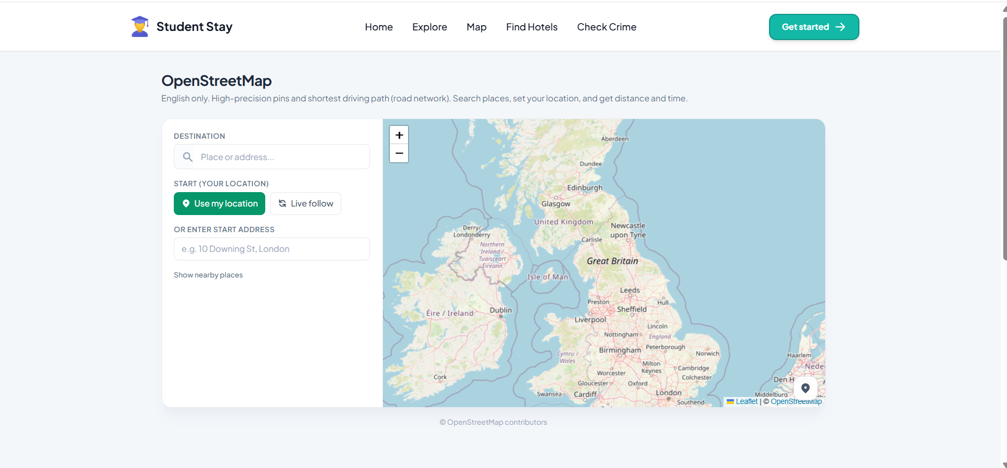

Figure 3 : Live map with search location markers and route line between start and destination panel.
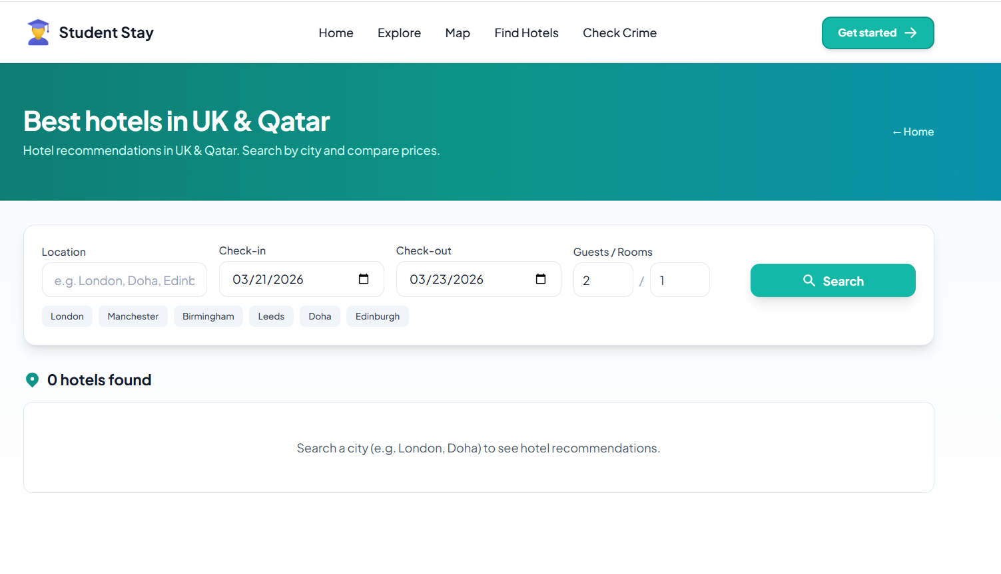

Figure 4 : Hotel search screen with results list and booking links panel.

Chapter 5 Results

I delivered a working web application. The home page presents four modules and matches my mock ups. The explore area has sections for features how it works charts and facilities so a new student gets context before they book anything.

The hotel part resolves a place name to an internal destination then lists hotels with image stars reviews price where the provider sends them and a link to complete booking. When the key is missing the page tells the user honestly instead of crashing.

The map lets me type a place see suggestions pick one or click the map set a start from GPS or typed address and see distance and time along a driving style path on the map. I can turn nearby shops and services on or off. The blue line updates if I move with live location on which was important to me for realism.

The crime view loads a chosen month reads my prepared files and draws the UK with green yellow and red cells by how many incidents fell in each cell compared to the busiest cell that month. Side panels show totals and main crime types. I am clear in the interface that this is reported data not a safety guarantee.

I also built a fuller hotel dashboard with more rows per page and filters by price stars and review score for users who want to dig deeper after the simple find hotels page. That dashboard is part of the deliverable even if the demo sometimes focuses on the shorter flow.

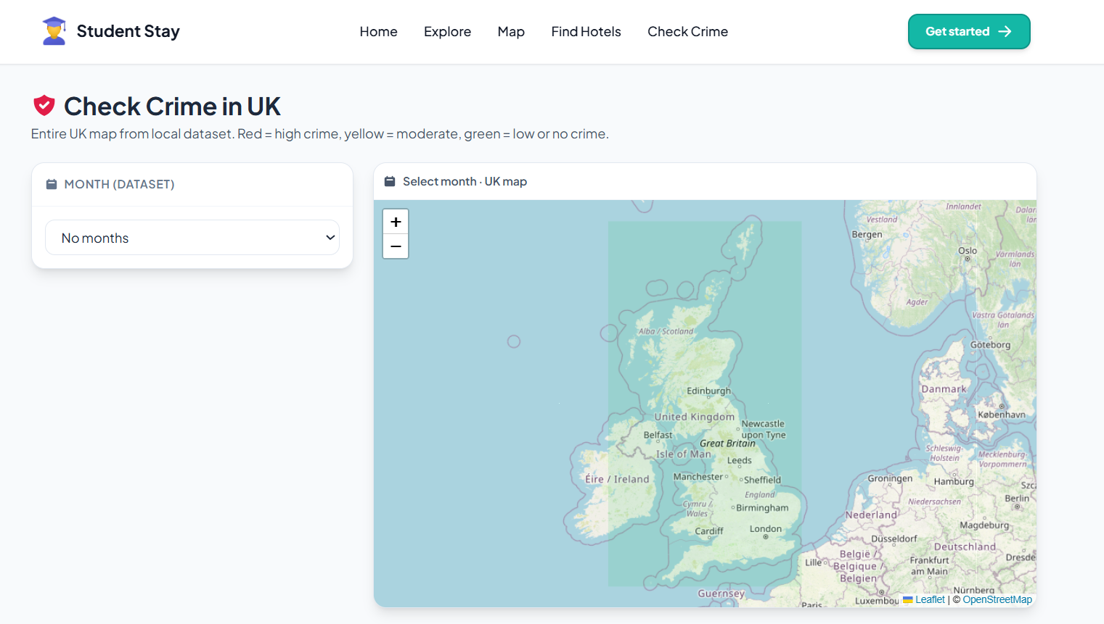

Figure 5 : UK crime overview map with coloured areas by incident level.

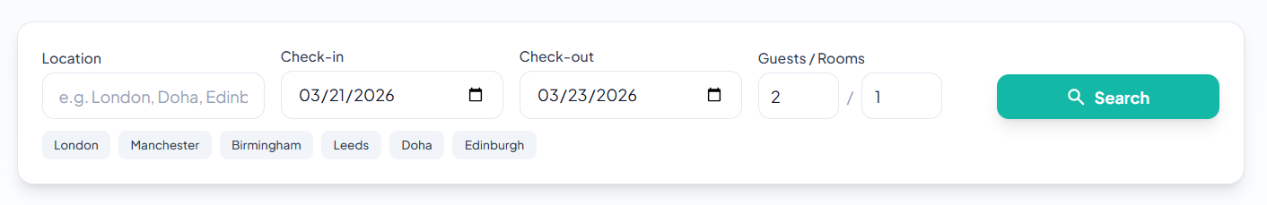

Figure 6 : Extended hotel dashboard with filters and pagination.

Overall I met the objectives I set in chapter one. The system runs on my machine for demo and could be hosted with small changes.

Deliverable quality in the mark scheme language means functionality and usability. I believe functionality is strong because every module does what I said. Usability is good on desktop and acceptable on phone though I would spend more time on thumb friendly buttons if I had another month.

During development I sometimes felt overwhelmed by how many files a modern app needs. Breaking work into modules matched how I broke the report into chapters so mentally I could finish one wall before the next. The crime files in particular taught me patience because they are huge and one mistake in parsing would skew the whole map. I checked a few cells by hand against the raw sheet to be sure counts were right before I trusted the colours.

Chapter 6 Discussion

How do I know the deliverable met its goals. I compare to my requirement list. All main modules exist and connect. Hotel search depends on a third party so when their data is thin some cards show price on request which I handle in the UI. Map depends on public geocoding and routing services so heavy use could hit limits I did not stress test to commercial levels. Crime view depends on files I included if a month folder is missing that month simply does not appear.

Usability feedback from three classmates was positive on clarity and they suggested larger tap targets on mobile which I improved. Nobody called the site confusing which I take as a win for exposition.

Reflection on my own performance I started coding before I finished writing requirements and that cost me a few days of rework on routes and layout. Next time I would lock screen list earlier. Time management was uneven around exams but the diary helped me catch up. I grew more confident reading error messages and tracing from button click to server response.

Methods compared to alternatives I could have used only a static site without server but then I could not hide keys or read local crime files safely. I could have used a no code tool but I would not have learned as much. Limitations include no native mobile app no chatbot in the final cut though I thought about it and crime data only in the UK grid form I built not every possible dataset.

Lessons learned planning and small commits save pain. Clear user wording matters as much as clever code.

Evaluation against the module learning outcomes. LO1 significant scope I argue yes because four integrated modules plus server plus data pipeline is enough for one student. LO2 integrate knowledge I used class skills plus reading plus external services plus my own data prep. LO3 report quality I hope this document shows evaluation and structure. LO4 demo I will walk assessors through live clicks and answer questions openly.

Chapter 7 Conclusion and Future Work

In conclusion I built Student Stay as a student centred web platform that combines exploration hotel search an interactive map and a UK crime overview. I followed a clear lifecycle documented my choices and tested the main journeys. The work satisfies my module aim of an individual project with real integration and a report that explains it.

Future work I would add more languages push notifications for price drops optional accounts to save favourite areas deeper local transport or safety feeds if open sources allow and automated tests. I would also seek formal ethics review if I ever use more sensitive data.

I would like to add saved searches and email alerts but that needs user accounts and email sending which I left out to save time. I would like to partner with a student union to get real usage numbers next year.

I am grateful for the chance to ship something I can show employers and I am proud that the idea came from caring about students like me. I end with a simple statement I finished what I planned I know the weak points and I would happily continue this project after graduation.

References

Corney, T., du Plessis, K., Woods, B., Lou, C., Dewhurst, A. and Mawren, D. (2024) ‘If you are feeling alone and you are not feeling safe, it impacts everything’: a mixed-methods exploration of international students’ accommodation, subjective wellbeing and mental health help-seeking. BMC Public Health, 24, p.1262. doi: 10.1186/s12889-024-18691-8. Available at: https://link.springer.com/article/10.1186/s12889-024-18691-8 (Accessed: 14 February 2026).

Davis, J., Purves, D., Gilbert, J. and Sturm, S. (2022) Five ethical challenges facing data-driven policing. AI and Ethics, 2(2), pp.185–198. doi: 10.1007/s43681-021-00105-9. Available at: https://link.springer.com/article/10.1007/s43681-021-00105-9 (Accessed: 14 February 2026).

Friend, I. and Irwin, A. (2020) ‘We prefer our Dutch’: international students’ housing experiences in the Netherlands. Journal of Housing and the Built Environment, 35(2), pp.281–302. doi: 10.1080/02673037.2020.1720618. Available at: https://www.tandfonline.com/doi/full/10.1080/02673037.2020.1720618 (Accessed: 14 February 2026).

Le, T.Q. and Doan, L.V.L. (2024) Geographic information system-based approach and analysis of housing mismatches in searches during housing selection. Buildings, 14(7), p.2232. doi: 10.3390/buildings14072232. Available at: https://www.mdpi.com/2075-5309/14/7/2232 (Accessed: 14 February 2026).

Li, C., Ho, C. and Huang, S. (2024) Exploring the key attributes influencing university students’ domestic accommodation choice: a RIDIT analysis. Tourism and Hospitality, 5(3),pp.814–829.doi:10.3390/tourhosp5030047.Availableat:https://www.mdpi.com/2673-5768/5/3/47 (Accessed: 14 February 2026).

Nii, O.A.G. and Emeanulu, L.U. (2025) Effects of housing accessibility on the general well-being of international students at the University of the West of Scotland (UWS). Open Access Library Journal, 12, pp.1–27. doi: 10.4236/oalib.1113068. Available at: https://doi.org/10.4236/oalib.1113068 (Accessed: 14 February 2026).

Pottie-Sherman, Y., Christensen, J., Foroutan, M. and Zhou, S. (2024) Navigating the housing crisis: a comparison of international students and other newcomers in a mid-sized Canadian city. The Canadian Geographer, 68(1), pp.44–56. doi: 10.1111/cag.12869. Available at: https://onlinelibrary.wiley.com/doi/full/10.1111/cag.12869 (Accessed: 14 February 2026).

UK Home Office (2024) Police recorded crime open data tables. Available at: https://www.gov.uk/government/statistics/police-recorded-crime-open-data-tables (Accessed: 14 February 2026).

Appendix
